Name: Class:
Introduction
The kinetic molecular theory (KMT) is a model used to explain the behaviour of gases. The essential ideas of this theory are:
- gaseous particles are in constant random motion, colliding with each other and the walls of the container
- the volume of each gas particle is negligible compared to the total gas volume
- forces between gas particles are negligible
- collisions are perfectly elastic; energy may be transferred between particles, but the average kinetic energy of the particles does not change
- average kinetic energy of the particles is proportional to the absolute temperature of the gas.

No. | Question | Answer
A sample of carbon dioxide gas is at room temperature and pressure. The sample is then compressed to a smaller volume, while keeping the temperature constant. How will this change the:
a pressure of the sample?
b average kinetic energy of the molecules?
c average speed of the molecules?
 | A 50 mL container is filled with nitrogen and sealed. The temperature is then raised by 20°C. Explain why the pressure increases when this change in temperature is made.
 | A short tube with a stopcock connects two flasks of equal volume. One flask contains oxygen at a pressure of 2 atm; the other is evacuated. What will happen when the stopcock is opened?
 | A syringe with a free-moving plunger contains nitrogen. Explain why the plunger will move in when the syringe is cooled.
A student has two 1.0 L flasks. Flask A contains methane (CH₄); flask B contains oxygen (O₂). Both flasks are at the same temperature and pressure, and so must contain an equal number of molecules. Which of these flasks:
a contains the greater mass of gas?
b has molecules with a higher average kinetic energy?
c has the greater density?
The graph below shows the distribution of molecular velocities in a gas sample at 20°C. On the same graph, sketch the expected curve for the same gas sample at 40°C.
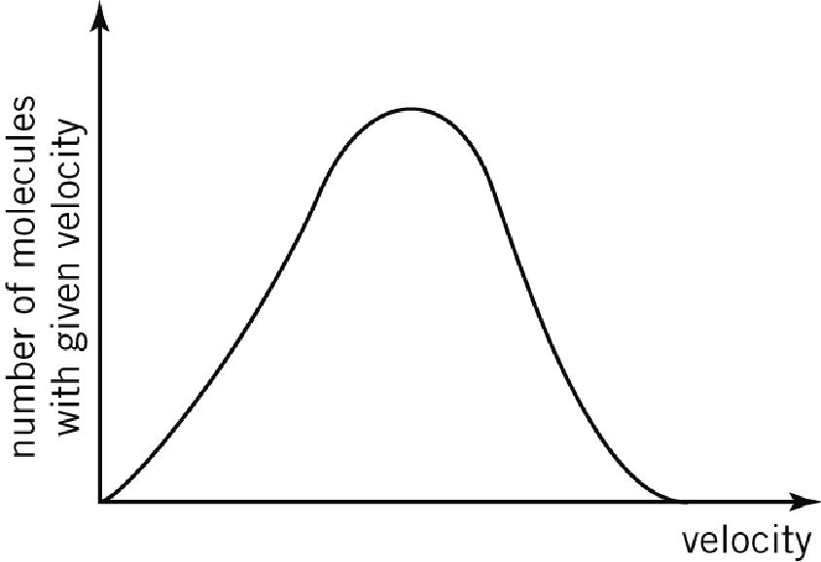
 | Some materials, like the rubber that a balloon is made of, have tiny holes through which gases can escape. If two identical balloons are filled with identical volumes of different gases (helium and nitrogen), which balloon would be more deflated after 24 hours? Explain your choice.
 | The KMT assumes that there are no forces between gas particles. Under what temperature and pressure conditions would forces between particles become significant?
 | When a helium balloon is released from ground level, explain why its volume increases as it rises in the atmosphere.

